**Review Worksheet ANSWERS: Homeostasis**

*.*

1: Define homeostasis

(2 marks)

*Homeostasis is the maintenance of internal body conditions (0.5) within a narrow range of values (0.5) – a steady state (0.5) so that organs and systems can continue to function (0.5)*

2: Why is it important to maintain a body temperature around 37oC?

(2 marks)

*If the temperature goes higher or lower than the set point (0.5), chemical reactions will not proceed at the correct pace (0.5), and proteins may not be able to maintain their shape (0.5). This would cause illness and death if uncorrected. (0.5)*

3: Why are homeostatic mechanisms important?

(2 marks)

*They are the ways in which the body maintains homeostasis (0.5) and allow some independence from the external environment (1). This provides a survival advantage (0.5)*

4: What is “dynamic equilibrium”?

(2 marks)

*Dynamic equilibrium is the fluctuation of the internal environment (0.5) within a narrow, acceptable range (0.5) to maintain normal body function (0.5). There is a constant process of sensing, responding and feedback to maintain it. (0.5)*

5: What are tolerance limits?

(2 marks)

*These are the upper and lower limits (0.5) for a homeostatic factor (0.5) between which normal function can occur (0.5). If tolerance limits are breached, dysfunction will occur. (0.5)*

6: What is thermoregulation?

(3 marks)

*Thermoregulation is the regulation of core body temperature at a 37oC set point (1), so that chemical reactions in cells are stable and optimised (1), and normal function can occur.(1)*

7: Describe some ways in which the body can gain heat from the external environment.

(3 marks)

*Via conduction (0.5) and radiation (0.5). For example, warm air or water in contact with skin conducts heat into the body (1). Solar radiation causes the body to heat up when standing in the sun. (1)*

8: Describe some ways that the body can lose heat to the external environment.

(2 marks)

*Via convection (0.5). Cold air or water in contact with skin moves heat away from the body (1). This includes evaporation of sweat. (0.5)*

9: Describe how the body can gain heat via internal processes:

(3 marks)

*Cellular respiration/metabolism produces heat as a by-product (1). When metabolic rate increases, heat production increases (1), for example during exercise or stress.(1)*

10: What are thermoreceptors and where are they located?

(11 marks)

*Thermoreceptors are sensory receptors (1) that detect temperature (1). The body contains peripheral thermoreceptors (1) in skin and surface tissues (1). These detect the temperature of the external environment (1) and send the information to the hypothalamus (1) via the sensory nervous system. (1)*

*The body also contains central thermoreceptors (1) in the hypothalamus, spinal cord and abdominal organs. (1) These detect core body temperature (1) and send signals to the hypothalamus.(1)*

11: Use your notes to develop homeostatic feedback loops (similar to the example given) for the following:

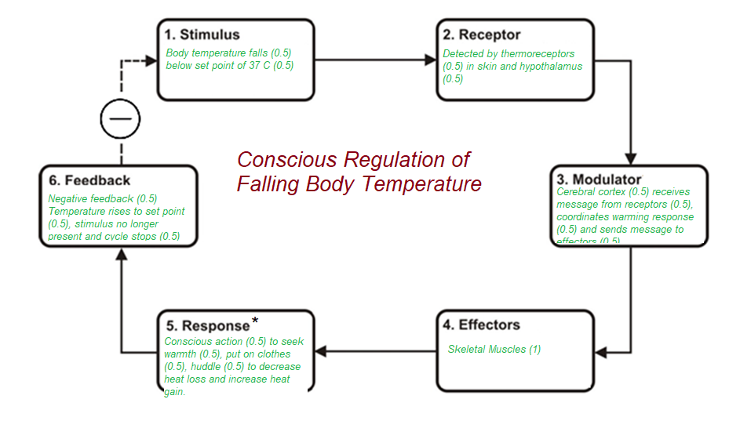

(10 marks)

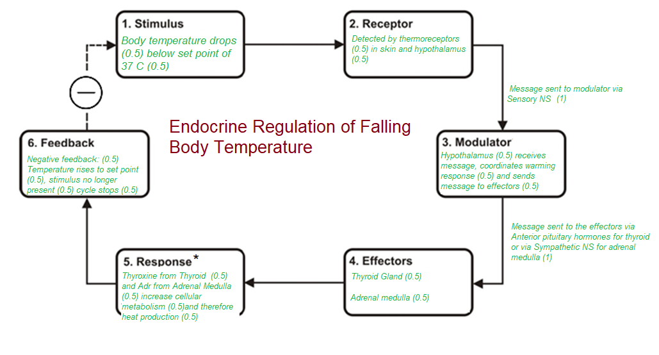

(10 marks)